

**The 10th International Conference on Network and System Security (NSS 2016)**

**September 28-30, 2016, Taipei, Taiwan**

**Call for Papers**

While the attack systems have become more easy-to-use, sophisticated, and powerful, interest has greatly increased in the field of building more effective, intelligent, adaptive, active and high performance defense systems which are distributed and networked. The conference will cover research on all theoretical and practical aspects related to network and system security, such as authentication, access control, availability, integrity, privacy, confidentiality, dependability and sustainability of computer networks and systems. The aim of NSS is to provide a leading edge forum to foster interaction between researchers and developers with the network and system security communities, and to give attendees an opportunity to interact with experts in academia, industry, and governments. NSS 2016 is the next event in a series of highly successful events of Network and System Security. Previous editions were held in: New York City, USA (2015), Xi'an, China (2014), Madrid, Spain (2013); Wu Yi Shan, China (2012); Milan, Italy (2011); Melbourne, Australia; (2010); Gold Coast, Australia (2009); Shanghai, China (2008); and Dalian, China (2007).

**Topics of interest include but are not limited to:**

|  |  |  |  |  |
| --- | --- | --- | --- | --- |
| - Active Defense Systems  - Adaptive Defense Systems  - Analysis, Benchmark of Security Systems  - Applied Cryptography  - Authentication  - Big Data Security and Privacy  - Biometric Security  - Complex Systems Security  - Database and System Security  - Data Protection  - Data/System Integrity  - Digital Forensics  - Distributed Access Control  - Distributed Attack Systems  - Denial-of-Service  - High Performance Network Virtualization | | - High Performance Security Systems  - Hardware Security  - Identity Management  - Intelligent Defense Systems  - Insider Threats  - Intellectual Property Rights Protection  - Internet and Network Forensics  - Intrusion Detection and Prevention  - Key Distribution and Management  - Large-scale Attacks and Defense  - Malware  - Network Resiliency  - Network Security  - RFID/NFC Security and Privacy  - Security Architectures  - Security for Critical Infrastructures | | - Security for Cyber Physical Systems  - Security in Cloud and Grid Systems  - Security in Pervasive/Ubiquitous Computing  - Security and Privacy in Smart Grid  - Security and Privacy in Social Networks  - Security and Privacy in Wireless Networks  - Secure Mobile Agents and Mobile Code  - Security Policy  - Security Protocols  - Security Simulation and Tools  - Security Theory and Tools  - Standards and Assurance Methods  - Trusted Computing  - Trust Management  - World Wide Web Security |
|  | |  | |  |
| **Submission Guidelines**  Submitted papers must not substantially overlap with papers that have been published or that are simultaneously submitted to a journal or a conference with proceedings. Papers must be clearly presented in English, must not exceed 14 pages, including tables, figures, references and appendixes, in Springer LNCS Format with Portable Document Format (.pdf). Please submit your paper at:  https://www.easychair.org/conferences/?conf=nss2016  Papers will be selected based on their originality, timeliness, significance, relevance, and clarity of presentation. Submission of a paper should be regarded as a commitment that, should the paper be accepted, at least one of the authors will register and attend the conference to present the work. | | **Honorary Chairs**  D. J. Guan, National Sun Yat-Sen University, Taiwan  Yen-Nun Huang, Academia Sinica, Taiwan  Der-Tsai Lee, Academia Sinica, Taiwan  **General Chairs**  Chun-I Fan, National Sun Yat-Sen University, Taiwan  Nai-Wei Lo, National Taiwan University of Science and Technology, Taiwan  Shiuhpyng (Winston) Shieh, National Chiao Tung University, Taiwan  Tzong-Chen Wu, National Taiwan University of Science and Technology, Taiwan  **Program Chairs**  Jiageng Chen, Central China Normal University, China  Vincenzo Piuri, University of Milan, Italy  Chunhua Su, Japan Advanced Institute of Science and Technology, Japan  Moti Yung, Columbia University, USA  **Executive Chairs**  Chen-Mou (Doug) Cheng, National Taiwan University, Taiwan  Wen-Chung Kuo, National Yunlin University of Science and Technology, Taiwan  Kuo-Hui Yeh, National Dong Hwa University, Taiwan  **Steering Chair**  Yang Xiang, Deakin University, Australia  C:\Users\Administrator.NDHU-20150311ML\Desktop\NSS 2016\2015.10.24 CFP\hdbg.jpgC:\Users\Administrator.NDHU-20150311ML\Desktop\NSS 2016\2015.10.24 CFP\lncs_logo.png**More** **Details**: <http://nsclab.org/nss2016/> | |
| **Important Dates**  Paper Submission Deadline: ~~15~~~~th~~ ~~May, 2016~~  30th May, 2016 (Firmed Deadline)  Author Notification: ~~15~~~~th~~ ~~June, 2016~~  10th July, 2016  Camera-ready and Registration: 22th July, 2016  Conference Dates: 28-30 September, 2016 | |

Selected papers will be invited to the following journal special issues:

1. Special Issue on “Advanced Persistent Threat,” **Future Generation Computer Systems**

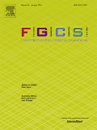(SCI indexed, Impact Factor: 2.786)

1. Special issue on “Recent Advances in Computational Intelligence Paradigms

for Privacy Preserving Security for Clouds Services,” **Cluster Computing**,

(SCIE indexed, Impact Factor: 1.51)



1. Special Issue on “Recent Advances of Information Systems in Security

and Privacy for Multimodal Network Environments,” **Telecommunication Systems**,

(SCIE indexed, Impact Factor: 0.705)



1. Special Issue on “Secure Computation on Encrypted Data,”

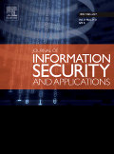**Journal of Information Security and Applications** (SCIE indexed)

1. Special Issue on “NSS 2016”, **Journal of Internet Technology**

(SCIE indexed, Impact Factor: 0.44)

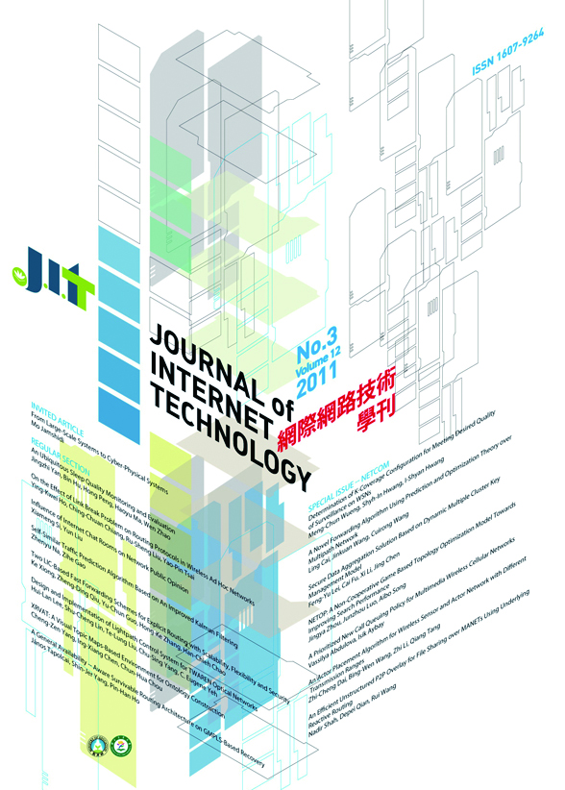

More journal special issues will be announced soon.